DEVOPS FINAL
Submitted by: FA23-BSCS-0213

Repository Link
Public GitHub repository: https://github.com/Muhammad-Arhan/project-phoenix/

Mission 1: The Pipeline Gatekeeper

Screenshot A — GitHub Actions: Pipeline Success
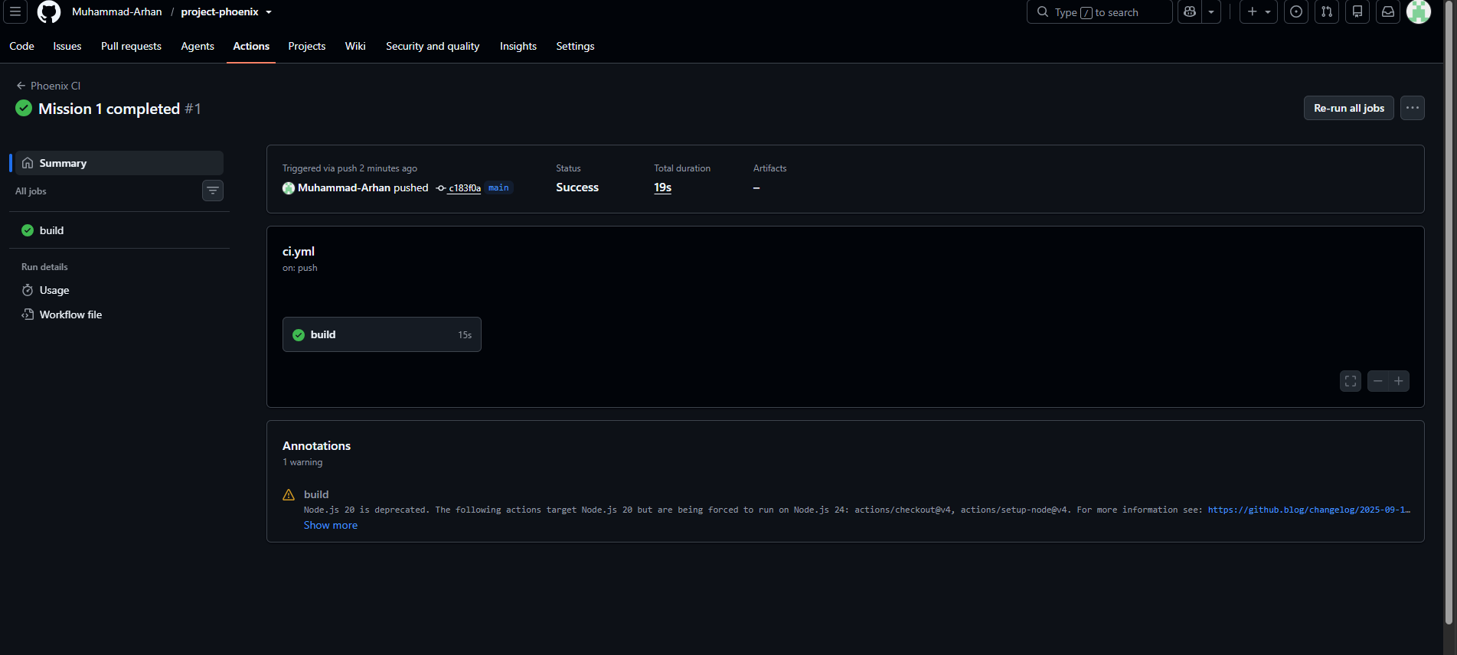

Screenshot A (continued) — Run Application Tests Step Expanded
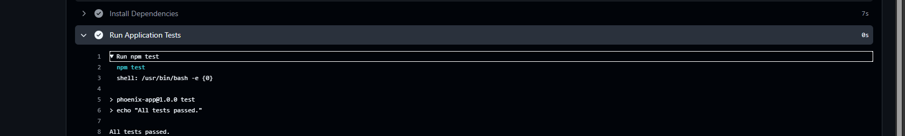

Mission 2: The Multi-Stage Monolith Build

Screenshot B — Docker Image Build & Size Verification

Mission 3: The Production Vault (Security & Bind Mounts)

Screenshot C — Container Running as Non-Root User
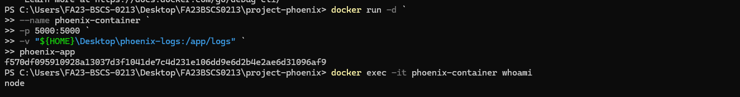

Screenshot D — Bind Mount Verified on Host Machine
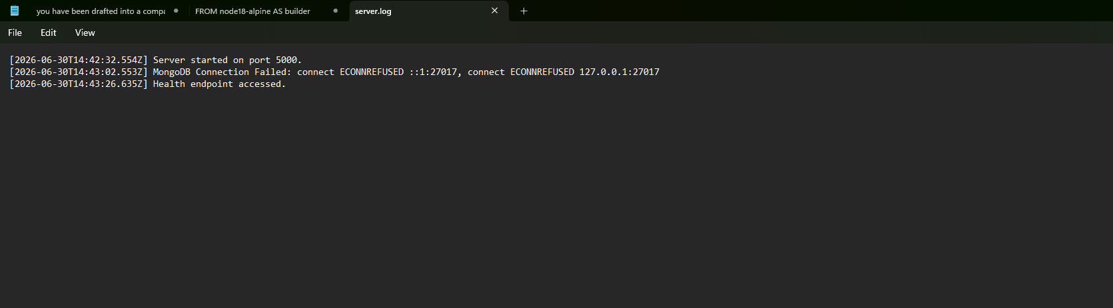

Mission 4: The Immortal Database (Docker Compose)

Screenshot E — Application Running via Docker Compose
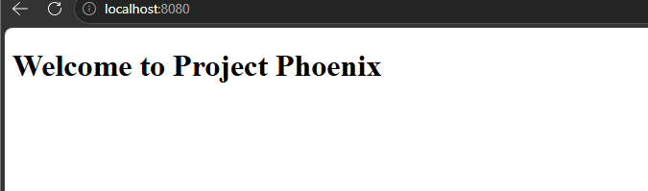

Screenshot F — Database Persistence Verified
